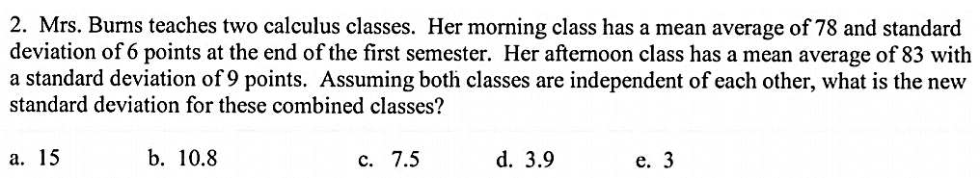



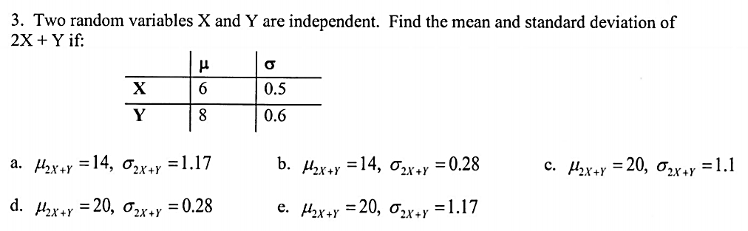



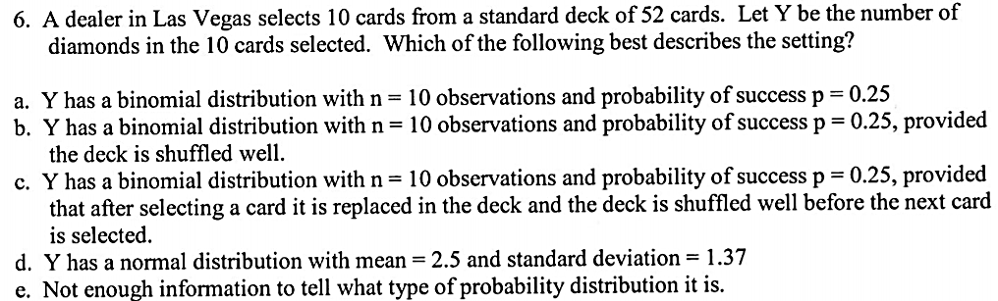

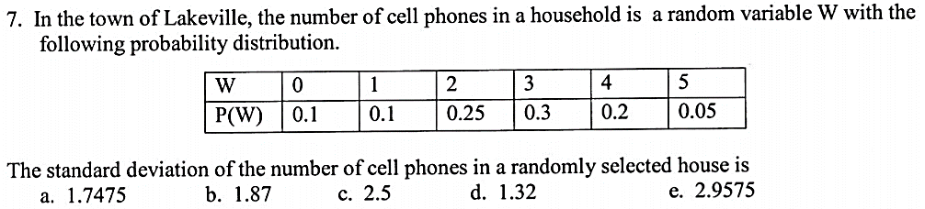

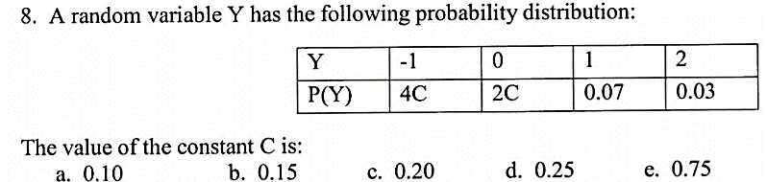

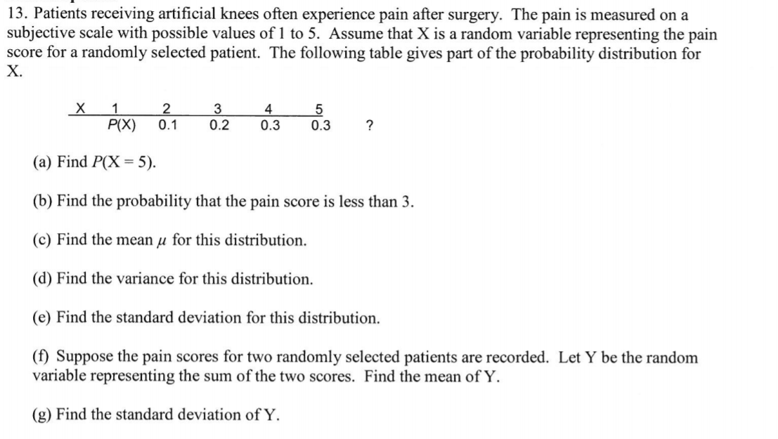

|  |  |  |  |  |  |
| --- | --- | --- | --- | --- | --- |
| X | 1 | 2 | 3 | 4 | 5 |
| P(X) | 0.1 | 0.2 | 0.3 | 0.3 | ? |





